ACE LEARNING PLUS CASE STUDY
PROJECT REPORT
INTRODUCTION
The Ace learning Plus is a learning institution base in Manchester, England, Uk. They were posed with a recuring questions as to know if academic success is solely dependent on classroom variable or external factors like home environment, nutrition, and assessment practices play pivotal roles in shaping students outcomes.
QUESTIONS
- Are females consistently outperforming males in reading/writing? Do males excel more in math?
- Which group is consistently underperforming or excelling across subjects
- Do students with parents holding a bachelor’s or master’s degree have higher academic performance?
- Is there a performance gap due to economic disadvantage?
- Is there a measurable benefit in math or writing scores from test prep?
CASE STUDY OBJECTIVES
DATA DESCRIPTION
Gender, race/ethnicity, parental level of education, lunch, test preparation course, math score, reading score , writing score.
DATA ANALYSIS PROCESS
PREPARE PHASE: The data to be used for this project is gotten from the school’s database system. For the purposes of this case study, the datasets are appropriate and will enable us to find solution to the business problems.
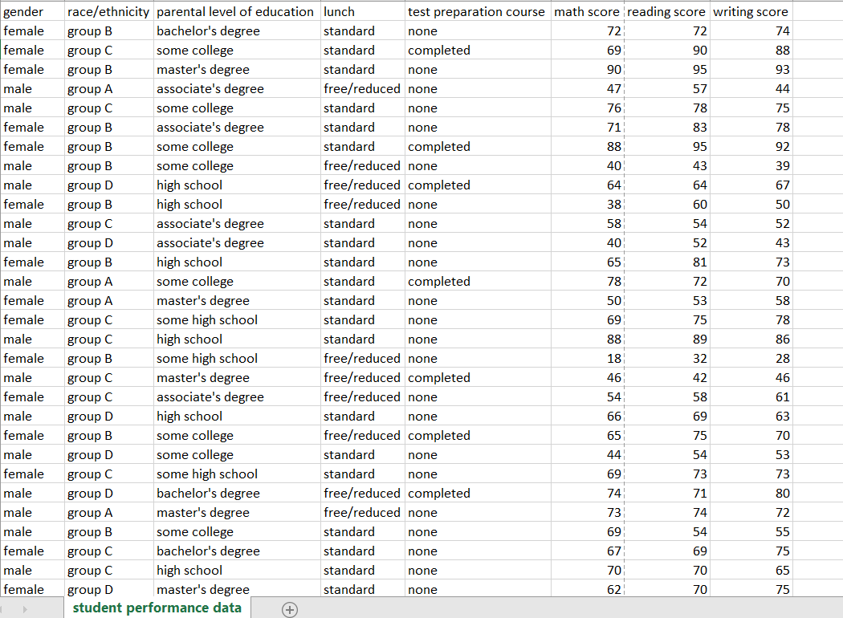
PROCESS PHASE
The following steps were taken to process the data
- Download the data from the schools’s database
- Unzip the files
- Create a folder on desktop to house the files. Use appropriate file-naming conventions.
- Create subfolders for the .csv file and the .xlsx or Sheets file so that original copy of data is available. Move the downloaded files to the appropriate subfolder.The cleaning was carried out in excel.
- Additional table called educational sort housing parental level of education and sort order was created and linked successfully in Power BI(Model view) to establish a one to many relationship so as to aid interactivity.
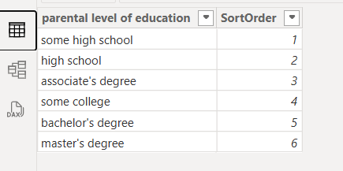
SHARE PHASE
After analysing the data, a visualization was made into to support and present key findings. The visualization below shows visuals highlighting the different key areas.
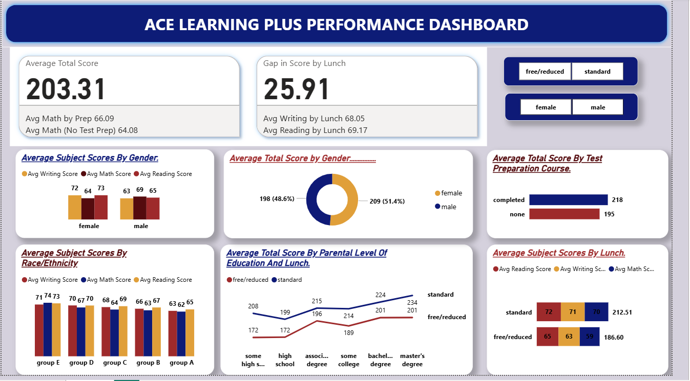
INSIGHTS/RECOMMENDATIONS
The dashboard shows that students perform better when their parents have higher education levels. It also reveals that students who eat lunch consistently outperform those who don’t . Additionally, pre-tests have a positive impact, with tested students achieving higher scores than those without pre-tests.

